|  |  |  |  |  |  |  |  |  |  |  |  |  |  |  |  |  |  |  |  |  |
| --- | --- | --- | --- | --- | --- | --- | --- | --- | --- | --- | --- | --- | --- | --- | --- | --- | --- | --- | --- | --- |
| **Revision History**   |  |  |  |  | | --- | --- | --- | --- | | **버전** | **날짜** | **작성자** | **변경내역** | | 0.2 | 2011/5/20 | 이동훈 | 초안 0.2 | | 0.5 | 2011/5/30 | 이동훈, 문장완, 김슬기 | 초안 0.5 | |  |  |  |  | |  |  |  |  | |

|  |  |  |  |  |
| --- | --- | --- | --- | --- |
| **Document Status**   |  |  |  |  | | --- | --- | --- | --- | | **유형** | Draft (초안) | **보안** | Confidential | |

OpenCL is a registered trademark of Apple Inc. used by permission by Khronos Group. All references to OpenCL components in this document are referenced from the publicly available OpenCL specification on the Khronos web-site at: <http://www.khronos.org/opencl>

NVIDIA, the NVIDIA logo, CUDA, and GeForce are trademarks or registered trademarks of NVIDIA Corporation.

Information furnished is believed to be accurate and reliable. However, PSC Group assumes no responsibility for the consequences of use of such information nor for any infringement of patents or other rights of third parties which may result from its use. No license is granted by implication or otherwise under any patent or patent rights of PSC Group. Specifications mentioned in this publication are subject to change without notice. This publication supersedes and replaces all information previously supplied. PSC Group products are not authorized for use as critical components in life support devices or systems without express written approval of PSC Group.

The PSC Group logo is a registered trademark of PSC Group.

All other names are the property of their respective owners

© 2011 PSC Group - All rights reserved

목차

Introducing 3

분석자료 3

1. GPGPU의 기반이 되는 Architecture 3

2. GPGPU 적용을 위한 Application 분석. 10

개발계획 (가칭 PSClib : Personal Super Computing Library) 11

1. PSClib 11

2. PSClib Block Diagram 12

관련자료 13

1. GPGPU를 이용한 어플리케이션 13

2. GPGPU 관련 서적 15

3. GPGPU 관련 IEEE 자료 20

# Introducing

본 문서는 ‘공개소프트웨어 기반의 개인용 슈퍼 컴퓨팅 플랫폼 구축 및 커뮤니티 운영’ 과제에 대한 개발 분석과 계획에 대하여 서술한 자료임.

# 분석자료

## GPGPU의 기반이 되는 Architecture

* 1. 초기 GPGPU Framework

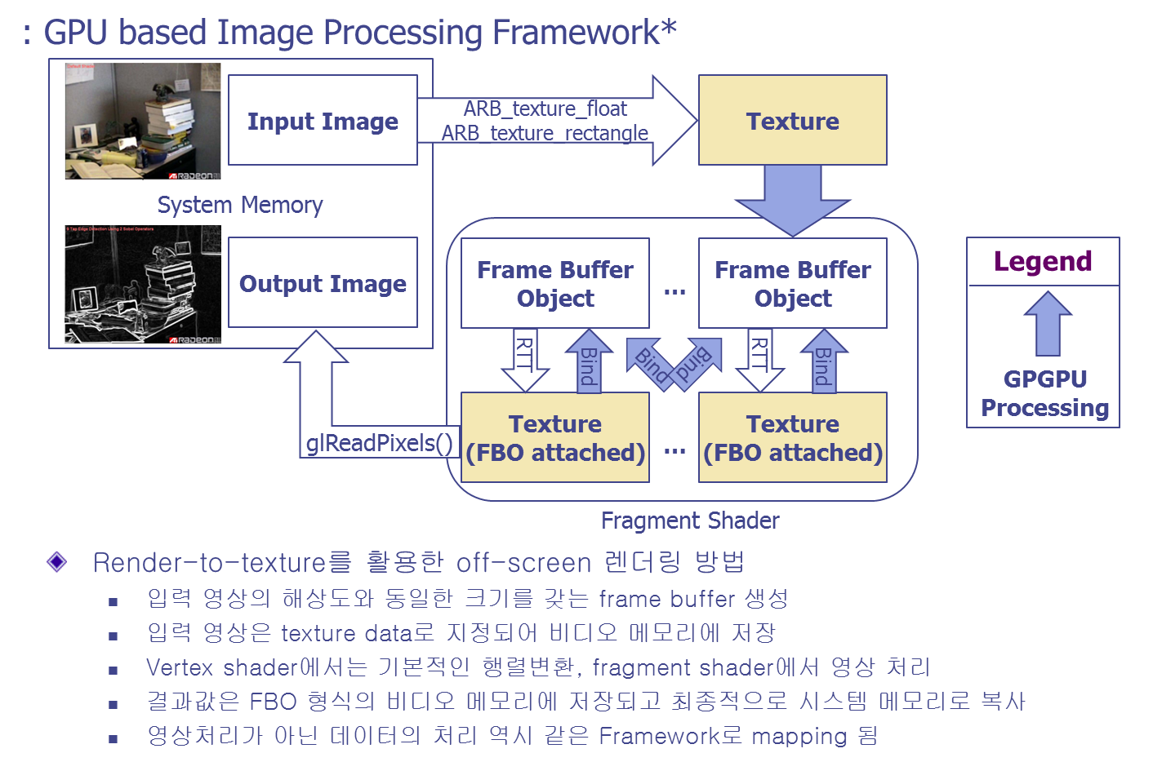

* Ref. : 이만희, 박인규, 원석진, 조성대, “GPU를 이용한 DWT 및 JPEG2000의 고속 연산”, 전자공학회 논문지, Vol.44-SP, No.6, pp.9-15, 2007년 11월

* 1. 엔비디아 CUDA 구조
     1. Block Diagram



* + 1. CUDA Software 개발환경

|  |  |
| --- | --- |
| Libraries | Advanced libraries that include BLAS, FFT, and other functions optimized for the CUDA architecture |
| C Runtime | The **C Runtime for CUDA** provides support for executing standard C functions on the GPU and allows native bindings for other high-level languages such as Fortran, Java, and Python |
| Tools | NVIDIA C Compiler (nvcc), CUDA Debugger (cudagdb), CUDA Visual Profiler (cudaprof), and other helpful tools |
| Documentation | Includes the CUDA Programming Guide, API specifications, and other helpful documentation |
| Samples | SDK code samples and documentation that demonstrate best practices for a wide variety GPU Computing algorithms and applications |

* + 1. CUDA 적용 Language

**Fortran:**

o Fortran wrapper for CUDA – <http://www.nvidia.com/object/cuda_programming_tools.html>

o FLAGON Fortran 95 library for GPU Numerics – <http://flagon.wiki.sourceforge.net/>

o PGI Fortran to CUDA compiler – <http://www.pgroup.com/resources/accel.htm>

**Java:**

o JaCuda – <http://jacuda.wiki.sourceforge.net>

o Bindings for CUDA BLAS and FFT libs – <http://javagl.de/index.html>

**Python:**

o PyCUDA Python wrapper – <http://mathema.tician.de/software/pycuda>

**.NET languages:**

o CUDA.NET – <http://www.gass-ltd.co.il/en/products/cuda.net>

**Resources for other languages:**

o SWIG – <http://www.swig.org> (generates interfaces to C/C++ for dozens of languages)

* 1. OpenCL
     1. OpenCL – Open Computing Language

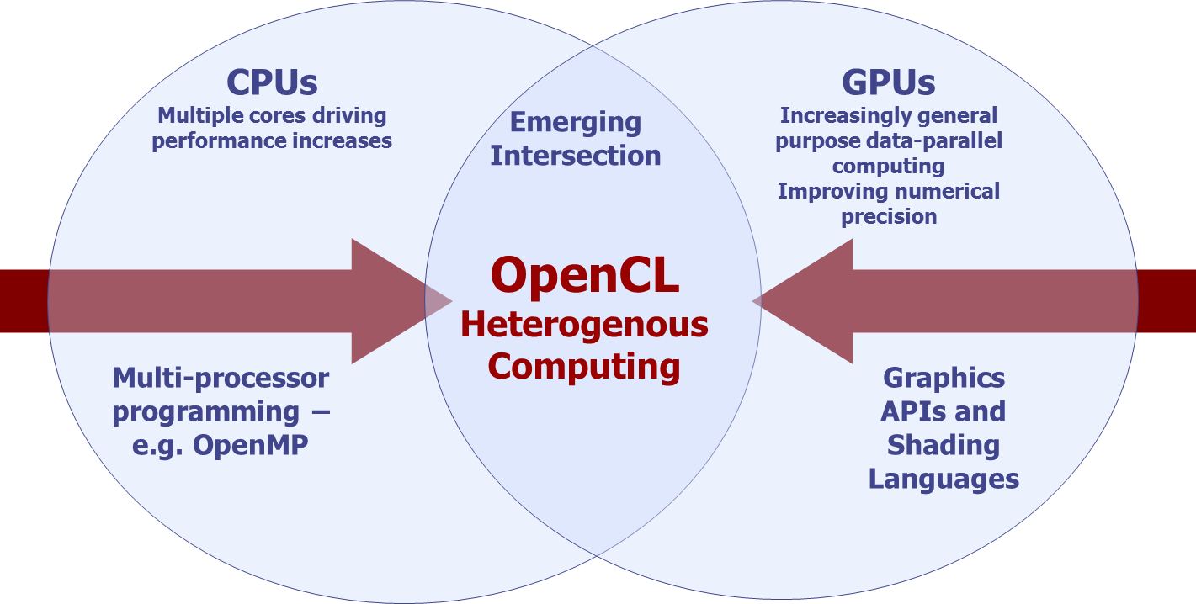

* + 1. OpenCL 적용 이전과 이후

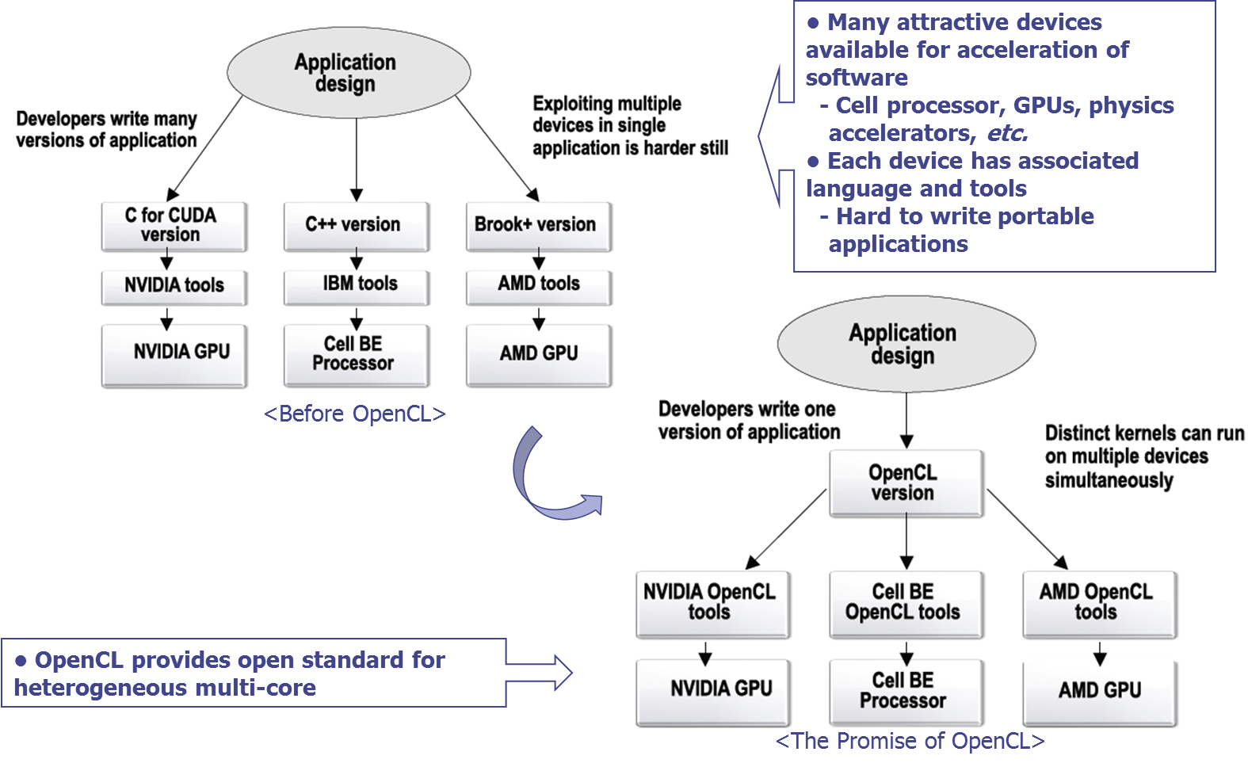

* + 1. OpenCL 조합

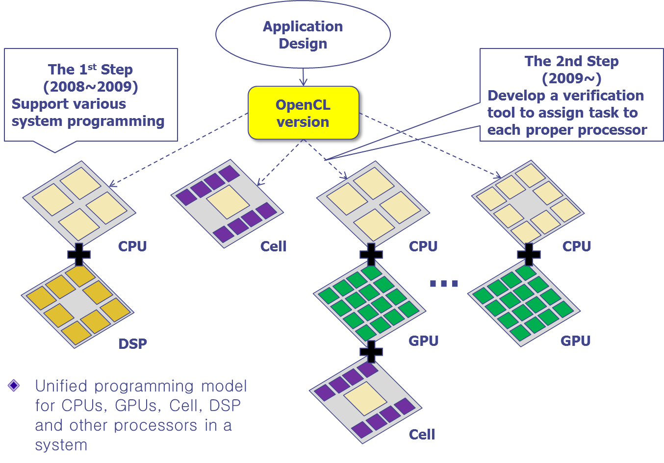

* + 1. OpenCL Software

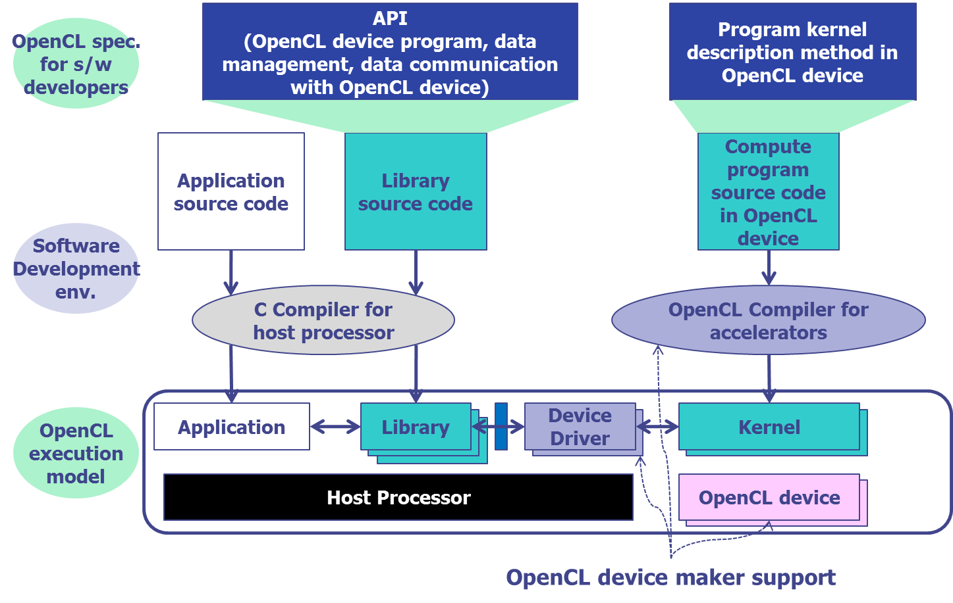

* + 1. OpenCL과 기타 표준과의 관계

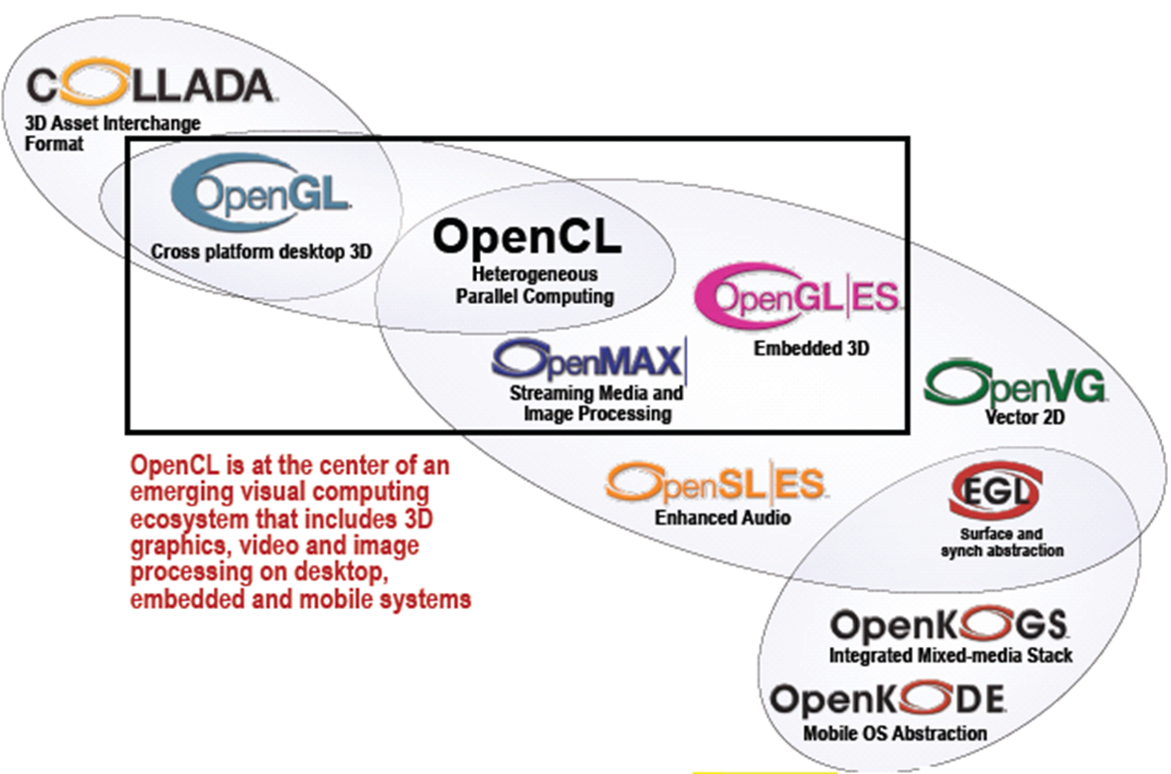

* + 1. OpenCL Platform Model

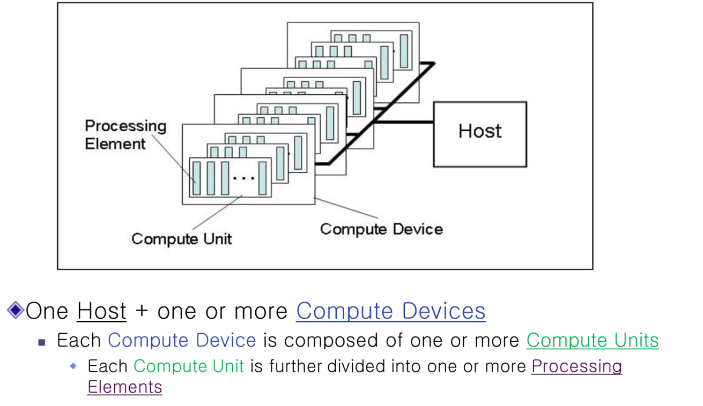

* + 1. OpenCL Memory Model

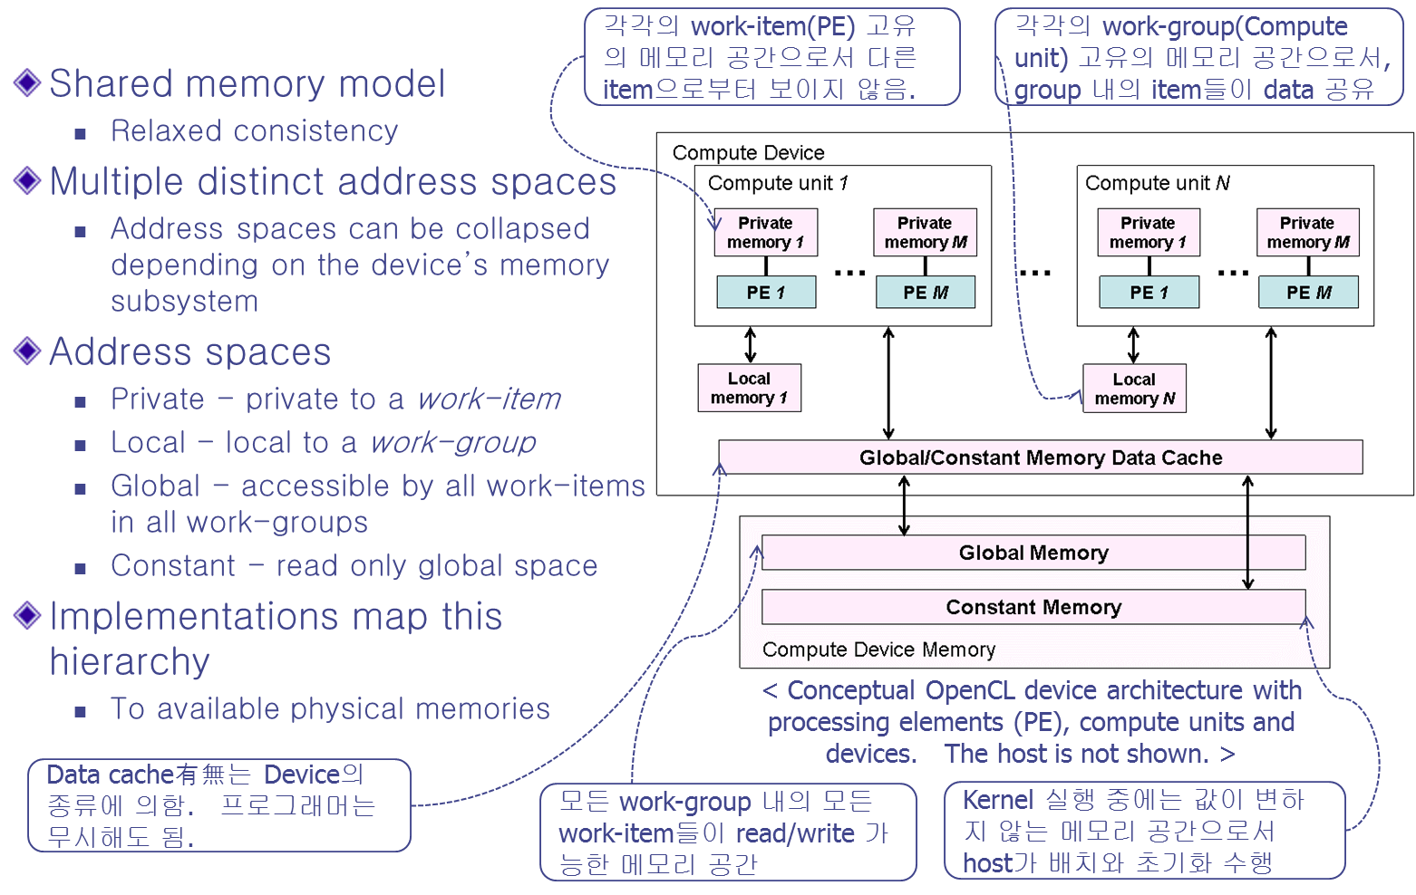

* + 1. OpenCL Kernel 실행

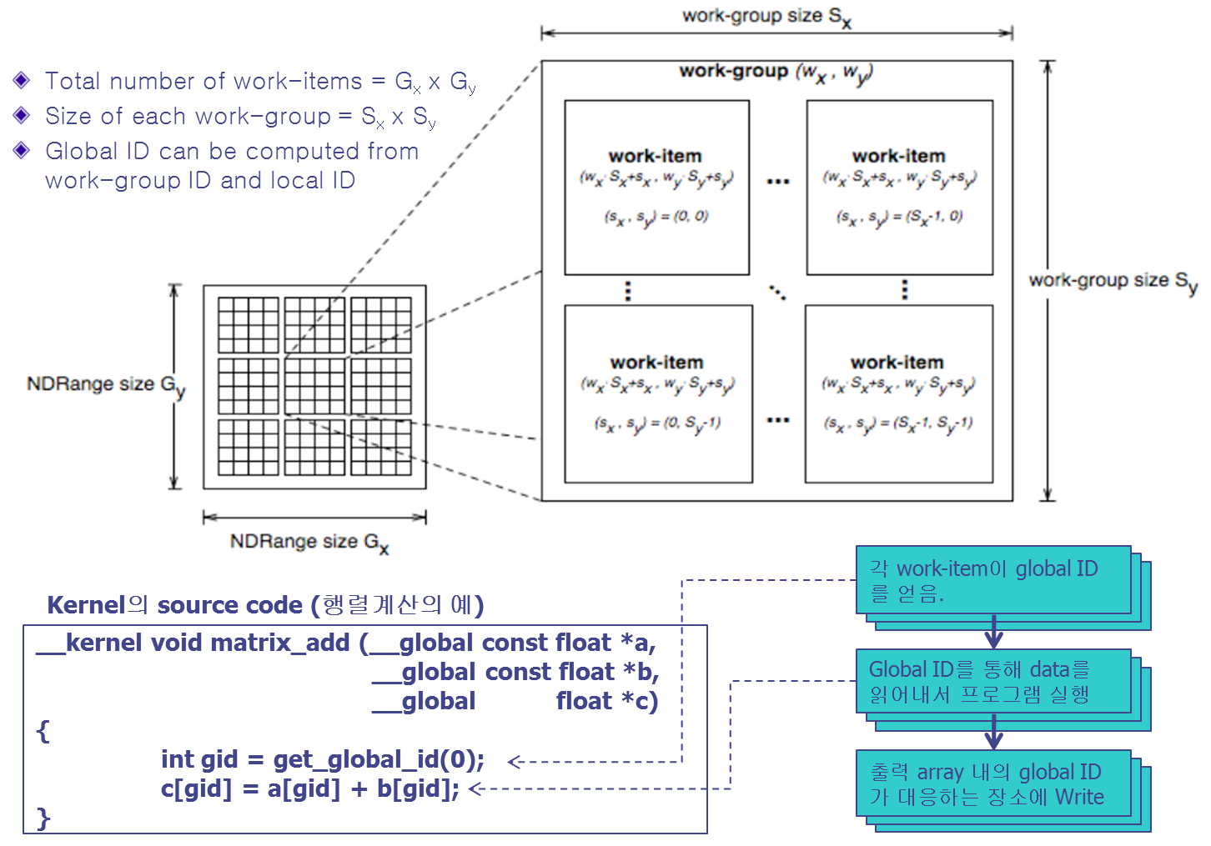

* + 1. OpenCL SDK 제공

Intel OpenCL SDK : <http://software.intel.com/en-us/articles/opencl-sdk/#resource>   
NVIDIA OpenCL SDK: <http://developer.nvidia.com/opencl>

AMD OpenCL SDK : <http://developer.amd.com/sdks/AMDAPPSDK/Pages/default.aspx>

* + 1. OpenCL Reference.

* OpenCL The Open Standard for Heterogeneous Parallel Programming, Neil Trevett(Khronos President) , Multicore Expo, March 2009

* OpenCL Technical Overview, John Roberts(NVidia), Multicore Expo, March 2009

* OpenCL as an intermediate language for heterogeneous multi-core programming, Alastair F. Donaldson(Codeplay Software Ltd. ), Multicore Expo, March 2009

* “Apple主導 の OpenCL プロセ サに 自由 をもたらす, Nikkei Electronics, Dec. 08, 2008

* Khronos Group : <http://www.khronos.org>

* The OpenCL Specification, version : 1.0, Document Revisions : 43, Khronos OpenCL Working Group

* Open Standard Industry Update from handhelds to supercomputers, Jon Peddie Research

## GPGPU 적용을 위한 Application 분석.

* 1. AutoDock Vina
     1. 기본 설명

O AutoDock Vina는 신약개발을 위한 Open Source Project

O Molecular docking, virtual screening 기능

O multi-core capability, high performance, 정확도 향상, 사용 용이성 제공

* + 1. 개발자

O Dr. Oleg Trott in the Molecular Graphics Lab at The Scripps Research Institute

* + 1. 결과 형상

flexible docking (green)의 결과가 crystal structures (a) indinavir, (b) atorvastatin, (c) imatinib, and (d) oseltamivir 각각 에 올려있는 모습

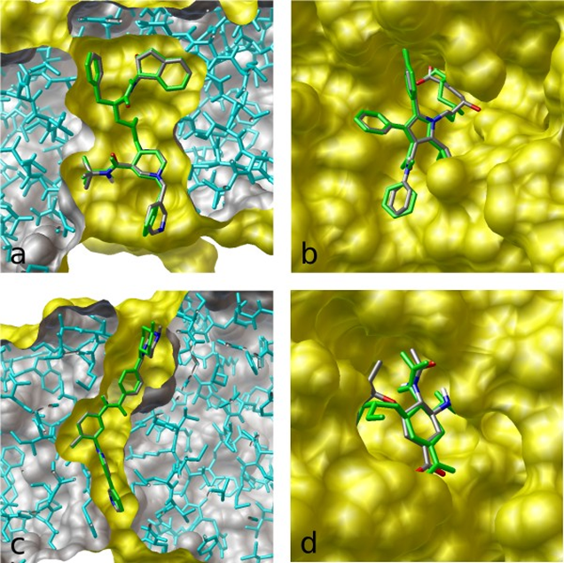

* + 1. 참고자료

<http://vina.scripps.edu/>

[O. Trott, A. J. Olson, AutoDock Vina: improving the speed and accuracy of docking with a new scoring function, efficient optimization and multithreading, *Journal of Computational Chemistry 31 (2010) 455-461*](http://www3.interscience.wiley.com/journal/122439542/abstract)

# 개발계획 (가칭 PSClib : Personal Super Computing Library)

## PSClib

* 1. 필요성

엔지니어, 과학자, 분석가, 기술 전문가들이 GPU를 이용한 데이터 분석 작업에 연산 성능을 최대한으로 이용할 수 있도록 지원. 최근 증대되는 이미지 데이터, 복잡한 분석 알고리즘, 수치해석 모델 등이 기존 CPU의 성능으로는 부족함을 느끼고 있기 때문에 GPU를 추가로 이용하는 것이 필요함.

* 1. 필요 기능

기존 CPU 프로그래밍을 하던 개발자들도 GPU 사용을 쉽게 할 수 있도록 지원해야 하며 이를 위한 해결 방안은 대용량 병렬 알고리즘이나 GPU 메모리 관리의 용이한 개발 환경이 필요함.

가속된 Mathematical, Image Filtering, Simulation Functions

Structural mechanics, fuid dynamics, earth, science, biosciences, medial/diagnostic imaging, financial engineering.

* 1. 참고자료

CUDA Web Site : <http://www.nvidia.com/cuda>

기타 본 문서 ‘관련자료’ 참조

## PSClib Block Diagram

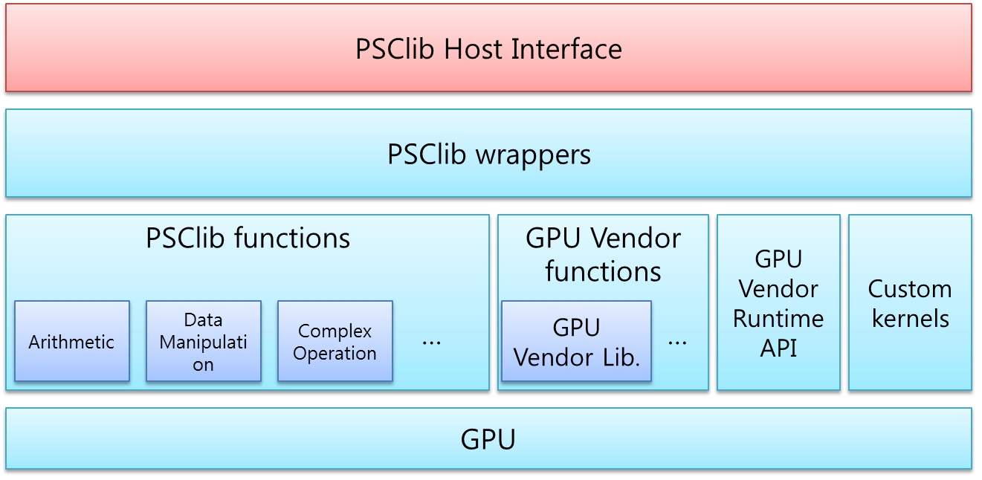

# 관련자료

## GPGPU를 이용한 어플리케이션

|  |  |
| --- | --- |
| **category** | **title** |
| **Government & Defense** | [RealityServer](http://www.nvidia.com/object/realityserver.html) |
| **Government & Defense** | [Ikena: Imagery Analysis and Video Forensics](http://www.motiondsp.com/products/Ikena) |
| **Government & Defense** | [Signal Processing Library: GPU VSIPL](http://gpu-vsipl.gtri.gatech.edu/) |
| **Government & Defense** | [IDL and MATLAB Acceleration: GPULib](http://www.txcorp.com/products/GPULib/) |
| **Government & Defense** | [GIS: Manifold](http://www.manifold.net/index.shtml) |
| **Government & Defense** | [MATLAB GPU Computing: MathWorks](http://www.nvidia.com/object/tesla-matlab-accelerations.html) |
| **Government & Defense** | [MATLAB Plugin: Accelereyes](http://www.accelereyes.com/) |
| **Molecular Dynamics, Computational Chemistry** | [OpenMM library for accelerating molecular dynamics on GPUs](https://simtk.org/project/xml/downloads.xml?group_id=161) |
| **Molecular Dynamics, Computational Chemistry** | [GROMACS using OpenMM](https://simtk.org/project/xml/downloads.xml?group_id=161#package_id600) |
| **Molecular Dynamics, Computational Chemistry** | [NAMD molecular dynamics](http://www.ks.uiuc.edu/Research/gpu/) |
| **Molecular Dynamics, Computational Chemistry** | [VMD visualization of molecular dynamics](http://www.ks.uiuc.edu/Research/gpu/) |
| **Molecular Dynamics, Computational Chemistry** | [HOOMD molecular dynamics](http://www.ameslab.gov/hoomd/) |
| **Molecular Dynamics, Computational Chemistry** | [Acellera: ACEMD bio-molecular dynamics package](http://www.acellera.com/index.php?arg=acemd) |
| **Molecular Dynamics, Computational Chemistry** | [BigDFT: DFT (Density functional theory) electronic structure code](http://inac.cea.fr/L_Sim/BigDFT/index.html) |
| **Molecular Dynamics, Computational Chemistry** | [MDGPU](http://www-old.amolf.nl/~vanmeel/mdgpu/about.html) |
| **Molecular Dynamics, Computational Chemistry** | [GPUGrid.net](http://www.gpugrid.net/) |
| **Molecular Dynamics, Computational Chemistry** | [MATLAB GPU Computing: MathWorks](http://www.nvidia.com/object/tesla-matlab-accelerations.html) |
| **Molecular Dynamics, Computational Chemistry** | [MATLAB plugin: Accelereyes](http://www.accelereyes.com/) |
| **Life Sciences, Bio-informatics** | [GPU HMMER](http://www.mpihmmer.org/) |
| **Life Sciences, Bio-informatics** | [DNA Sequence alignment: MUMmerGPU](http://sourceforge.net/projects/mummergpu/) |
| **Life Sciences, Bio-informatics** | [LISSOM: model of human neocortex using CUDA](http://code.google.com/p/lissom/) |
| **Life Sciences, Bio-informatics** | [Silicon Informatics: AutoDock](http://www.siliconinformatics.com/) |
| **Life Sciences, Bio-informatics** | [MATLAB plugin: Accelereyes](http://www.accelereyes.com/) |
| **Electrodynamics and electromagnetic** | [Acceleware: FDTD Solver](http://www.acceleware.com/fdtd-solvers) |
| **Electrodynamics and electromagnetic** | [Acceleware: EM Solutions](http://www.acceleware.com/electromagnetic-solutions) |
| **Electrodynamics and electromagnetic** | [Remcom XStream FDTD](http://www.remcom.com/xf7-xstream/) |
| **Electrodynamics and electromagnetic** | [SPEAG Semcad X](http://www.semcad.com/simulation/features/hardware.php) |
| **Electrodynamics and electromagnetic** | [CST Microwave Studio](http://www.cst.com/Content/Products/MWS/GPU.aspx) |
| **Electrodynamics and electromagnetic** | [Quantum electrodynamics library](http://code.google.com/p/aeth-drive/) |
| **Electrodynamics and electromagnetic** | [GPMAD : Particle beam dynamics simulator](http://www.hep.manchester.ac.uk/gpmad/) |
| **Medical Imaging, CT, MRI** | [RealityServer](http://www.nvidia.com/object/realityserver.html) |
| **Medical Imaging, CT, MRI** | [GPULib:IDL acceleration](http://www.txcorp.com/products/GPULib/) |
| **Medical Imaging, CT, MRI** | [Acceleware: Imaging Solutions](http://www.acceleware.com/imaging-solutions) |
| **Medical Imaging, CT, MRI** | [Digisens: SnapCT tomographic reconstruction software](http://www.digisens.fr/snapct/) |
| **Medical Imaging, CT, MRI** | [Techniscan: Whole Breast Ultrasound Imaging System](http://www.techniscanmedicalsystems.com/) |
| **Medical Imaging, CT, MRI** | [NVPP: NVIDIA Performance Primitives (early access)](http://www.nvidia.com/nvpp) |
| **Medical Imaging, CT, MRI** | [MATLAB GPU Computing: MathWorks](http://www.nvidia.com/object/tesla-matlab-accelerations.html) |
| **Medical Imaging, CT, MRI** | [MATLAB plugin: Accelereyes](http://www.accelereyes.com/) |
| **Oil & Gas** | [RealityServer](http://www.nvidia.com/object/realityserver.html) |
| **Oil & Gas** | [Acceleware: Kirchoff and Reverse Time Migration](http://www.acceleware.com/default/index.cfm/solutions/seismic-solutions/) |
| **Oil & Gas** | [SeismicCity: 3D seismic imaging for prestack depth migration](http://www.seismiccity.com/) |
| **Oil & Gas** | [OpenGeoSolutions: Spectral decomposition and inversion](http://www.opengeosolutions.com/) |
| **Oil & Gas** | [Mercury Computer systems: 3D data visualization](http://3dviz.mc.com/solutions/oilandgas/ngog/) |
| **Oil & Gas** | [ffA: 3D Seismic processing software](http://www.ffa.co.uk/) |
| **Oil & Gas** | [Headwave: Prestack data processing](http://www.headwave.com/) |
| **Oil & Gas** | [GIS: Manifold](http://www.manifold.net/index.shtml) |
| **Oil & Gas** | [MATLAB GPU Computing: MathWorks](http://www.nvidia.com/object/tesla-matlab-accelerations.html) |
| **Oil & Gas** | [MATLAB plugin: Accelereyes](http://www.accelereyes.com/) |
| **Financial computing and options pricing** | [SciComp: derivatives pricing](http://www.scicomp.com/parallel_computing/GPU_OpenMP) |
| **Financial computing and options pricing** | [Hanweck: options pricing](http://www.hanweckassoc.com/home.html) |
| **Financial computing and options pricing** | [Exegy: Risk Analysis](http://www.exegy.com/PDFs/WHT-0001-A_final.pdf) |
| **Financial computing and options pricing** | [Aqumin: 3D Visualization of market data](http://www.aqumin.com/) |
| **Financial computing and options pricing** | [Level 3 Finance](http://www.level3finance.com/) |
| **Financial computing and options pricing** | [OnEye (Australia): Accelerated Trading Solutions](http://www.oneye.com.au/) |
| **Financial computing and options pricing** | [Arbitragis Trading](http://www.arbitragis-research.com/cuda-in-computational-finance) |
| **Financial computing and options pricing** | [Enabling GPU Computing in the R Statistical Environment](http://brainarray.mbni.med.umich.edu/brainarray/rgpgpu/) |
| **Financial computing and options pricing** | [MATLAB GPU Computing: MathWorks](http://www.nvidia.com/object/tesla-matlab-accelerations.html) |
| **Financial computing and options pricing** | [MATLAB plugin: Accelereyes](http://www.accelereyes.com/) |
| **Math** | [CUDA Acceleration for MATLAB](http://www.nvidia.com/object/tesla-matlab-accelerations.html) |
| **Math** | [Accelereyes: Jacket engine for MATLAB](http://www.accelereyes.com/) |
| **Math** | [GPULib: mathematical functions for IDL and MATLAB](http://www.txcorp.com/products/GPULib/) |
| **Math** | [Integrating Simulink with CUDA using S-functions](http://www.cs.ucf.edu/~janaka/gpu/documentation.htm) |
| **Math** | [Enabling GPU Computing in the R Statistical Environment](http://brainarray.mbni.med.umich.edu/brainarray/rgpgpu/) |
| **Math** | [Mathematica plug-in for CUDA](http://hpc.nomad-labs.com/?p=8) |
| **Math** | [Using NVIDIA GPUs with National Instruments LabView](http://decibel.ni.com/content/docs/DOC-6064) |
| **Electronic Design Automation** | [Agilent EESof: ADS SPICE simulator](http://www.home.agilent.com/agilent/product.jspx?nid=-34346.0.00&cc=US&lc=eng) |
| **Electronic Design Automation** | [Synopsys: Sentaraus TCAD](http://www.synopsys.com/Tools/TCAD/Pages/default.aspx) |
| **Electronic Design Automation** | [Gauda: Optical proximity correction (OPC)](http://www.gauda.com/) |
| **Weather and Ocean Modeling** | [CUDA-accelerated WRF code](http://www.mmm.ucar.edu/wrf/WG2/GPU/) |
| **Video, Imaging, and Vision Applications** | [Axxon Intellect Enterprise Video Surveillance Software](http://www.axxonsoft.com/products/axxon_enterprise/) |
| **Video, Imaging, and Vision Applications** | [Pflow CUDA Plugin for Autodesk 3ds Max](http://www.zhangy.com/main/index.php?module=documents&JAS_DocumentManager_op=viewDocument&JAS_Document_id=26) |
| **Video, Imaging, and Vision Applications** | [RUINS Shatter CUDA Plug-in for Maya](http://www.nshatter.com/index.html) |
| **Video, Imaging, and Vision Applications** | [Bullet 3D Multi-Physics Library with CUDA Support](http://code.google.com/p/bullet/downloads/list) |
| **Video, Imaging, and Vision Applications** | [CUDA Voxel Rendering Engine](http://voxels.blogspot.com/) |
| **Video, Imaging, and Vision Applications** | [NVPP: NVIDIA Performance Primitives (early access) Volume Rendering with CUDA for VTK / Slicer3](http://www.slicer.org/slicerWiki/index.php/Slicer3:Volume_Rendering_With_Cuda) |
| **Video, Imaging, and Vision Applications** | [Furryball: Direct3D GPU Rendering Plugin for Maya](http://furryball.aaa-studio.cz/) |
| **Video, Imaging, and Vision Applications** | [For consumer CUDA applications, visit NZone](http://www.nzone.com/page/nzone_section_andmore.html) |

출처 : CUDA-Accelerated Applications ( <http://www.nvidia.com/object/cuda_app_tesla.html> )

## GPGPU 관련 서적

|  |  |  |  |  |
| --- | --- | --- | --- | --- |
| **Front Cover** | **Title** | **Autor / Editor** | **Date** | **Publisher** |
| |  | | --- | |  | | [Opencl Programming Guide](http://www.amazon.com/gp/search?keywords=9780321749642+Aaftab+Munshi%3BBenedict+Gaster%3BTimothy+G.+Mattson%3BJames+Fung+Opencl+Programming+Guide&tag=collectorzapp-20&index=books) | Aaftab Munshi; Benedict Gaster; Timothy G. Mattson; James Fung | 2011-7-25 | Addison-Wesley Professional |
| GPU Pro 2   |  | | --- | |  | | [GPU Pro 2](http://www.amazon.com/GPU-Pro-2-Wolfgang-Engel/dp/1568817185/ref=pd_sim_b_3) | Wolfgang Engel | 2011-02-14 | A K Peters/CRC Press |
| |  | | --- | |  | | [Gpu Computing Gems Emerald Edition](http://www.amazon.com/GPU-Computing-Gems-Emerald-Applications/dp/0123849888/ref=sr_1_1?ie=%20UTF8&s=books&qid=1298081179&sr=1-1) | Wen-mei W. Hwu | 2011-2-7 | Elsevier Science & Technology |
| |  | | --- | |  | | [Scientific Computing with Multicore and Accelerators (Chapman & Hall/CRC Computational Science)](http://www.amazon.com/Scientific-Computing-Multicore-Accelerators-Computational/dp/143982536X/ref=pd_sim_b_5) | Jakub Kurzak, David A. Bader, Jack Dongarra | 2010-12-07 | CRC Press |
| |  | | --- | |  | | [Cuda By Example: An Introduction to General-Purpose GPU Programming (OpenCL입문 - GPU와 멀티코어 CPU 병렬 프로그래밍)](http://www.amazon.com/CUDA-Example-Introduction-General-Purpose-Programming/dp/0131387685/ref=sr_1_1?ie=UTF8&s=books&qid=1271458526&sr=1-1) | Jason Sanders; Edward Kandrot | 2010-7-29 | Addison-Wesley |
| |  | | --- | |  | | [GPU Pro: Advanced Rendering Techniques](http://www.amazon.com/GPU-Pro-Advanced-Rendering-Techniques/dp/1568814720/ref=pd_sim_b_2) | Wolfgang Engel | 2010-07-01 | A K Peters |
| |  | | --- | |  | | [Opencl入門 - GPU&マルチコアCPU並列プログラミング for MacOS Windows Linux (OpenCL입문 - GPU와 멀티코어 CPU 병렬 프로그래밍)](http://www.amazon.co.jp/OpenCL%E5%85%A5%E9%96%80%E2%80%95GPU-%E3%83%9E%E3%83%AB%E3%83%81%E3%82%B3%E3%82%A2CPU%E4%B8%A6%E5%88%97%E3%83%97%E3%83%AD%E3%82%B0%E3%83%A9%E3%83%9F%E3%83%B3%E3%82%B0-MacOS-Windows-Linux/dp/4798026085/ref=pd_sim_b_2) | 奥薗隆司 | 2010-5-1 | インプレスジャパン |
| OpenCL Programming Book   |  | | --- | |  | | [The OpenCL Programming Book](http://www.fixstars.com/en/company/books/opencl/) | Ryoji Tsuchiyama, Takashi Nakamura, Takuro Iizuka, Akihiro Asahara, Satoshi Miki | 2010-03-31 | Fixstars Corporation |
| |  | | --- | |  | | [Cuda高速gpuプログラミング入門 (CUDA 고속 GPU 프로그래밍 입문)](http://www.amazon.co.jp/CUDA%E9%AB%98%E9%80%9FGPU%E3%83%97%E3%83%AD%E3%82%B0%E3%83%A9%E3%83%9F%E3%83%B3%E3%82%B0%E5%85%A5%E9%96%80-%E5%B2%A1%E7%94%B0-%E8%B3%A2%E6%B2%BB/dp/479802578X) | 岡田賢治 | 2010-3-1 | 秀和システム |
| |  | | --- | |  | | [Programming Massively Parallel Processors](http://www.amazon.com/dp/0123814723?tag=wwwnvidiacomc-20&camp=14573&creative=327641&linkCode=as1&creativeASIN=0123814723&adid=1DT2S034DXS37V3K5FFY) | David Kirk; Wen-mei W. Hwu | 2010-2-5 | Elsevier Science & Technology |
| |  | | --- | |  | | [Opencl入門 - マルチコアCPU・GPUのための並列プログラミング (OpenCL 입문 - 멀티코어 CPU, GPU를 위한 병렬 프로그래밍)](http://www.amazon.co.jp/gp/product/484432814X/ref=s9_simh_gw_p14_i3?pf_rd_m=A1VC38T7YXB528&pf_rd_s=center-1&pf_rd_r=05AHKA1S633NCTMCKSS4&pf_rd_t=101&pf_rd_p=463376736&pf_rd_i=489986) | 株式会社フィックスターズ, 土山 了士, 中村 孝史, 飯塚 拓郎, 浅原 明広, 三木 聡 | 2010-1-22 | インプレスジャパン |
| OpenCL並列プログラミング―マルチコアCPU/GPUのための標準フレームワーク   |  | | --- | |  | | [Opencl並列プログラミング - マルチコアCPU/GPUのための標準フレームワーク(OpenCL 병렬 프로그래밍 - 멀티코어 CPU/GPU를 위한 표준 프레임워크)](http://www.amazon.co.jp/OpenCL%E4%B8%A6%E5%88%97%E3%83%97%E3%83%AD%E3%82%B0%E3%83%A9%E3%83%9F%E3%83%B3%E3%82%B0%E2%80%95%E3%83%9E%E3%83%AB%E3%83%81%E3%82%B3%E3%82%A2CPU-GPU%E3%81%AE%E3%81%9F%E3%82%81%E3%81%AE%E6%A8%99%E6%BA%96%E3%83%95%E3%83%AC%E3%83%BC%25E) | 池田成樹 | 2010-1-1 | カットシステム |
| |  | | --- | |  | | [はじめての Cuda プログラミング - 驚異の開発環境[GPU+CUDA]を使いこなす! (처음 배우는 CUDA 프로그래밍 - 경이적인 개발환경[GPU+CUDA]을 자유자재로!)](http://www.amazon.co.jp/gp/product/4777514773/ref=s9_simh_gw_p14_i2?pf_rd_m=A1VC38T7YXB528&pf_rd_s=center-1&pf_rd_r=05AHKA1S633NCTMCKSS4&pf_rd_t=101&pf_rd_p=463376736&pf_rd_i=489986) | 青木尊之; 額田彰 | 2009-11-1 | 工学社 |
| |  | | --- | |  | | [GPU高性能运算之CUDA (GPU 고성능 연산 CUDA)](http://www.amazon.cn/mn/detailApp/ref=sr_1_1?_encoding=UTF8&s=books&qid=1271459625&asin=B002U848C6&sr=8-1) | 张舒, 褚艳利 | 2009-10-1 | DynoMedia Inc. |
| |  | | --- | |  | | [基于GPU的多尺度离散模拟并行计算 (GPU 기반의 다척도 이산시뮬레이션 병렬연산)](http://www.amazon.cn/mn/detailApp/ref=sr_1_2?_encoding=UTF8&s=books&qid=1271459625&asin=B001SVC3Z0&sr=8-2) | 多相复杂系列国家重点实验室, 多尺度离散模拟项目组 | 2009-1-1 | 科学出版社 |
| |  | | --- | |  | | [Process Algebra For Parallel And Distributed Processing (Chapman & Hall/Crc Computational Science Series)](http://www.amazon.com/gp/product/142006486X?tag=collectorzapp-20) | Michael Alexander; William Gardner | 2008-12-22 | Chapman & Hall/CRC |
| |  | | --- | |  | | [The Art of Multiprocessor Programming](http://www.amazon.com/Art-Multiprocessor-Programming-Maurice-Herlihy/dp/0123705916/ref=pd_sim_b_4) | Maurice Herlihy, Nir Shavit | 2008-03-14 | Morgan Kaufmann |

* 출처 : 1) NVIDIA - CUDA & GPU 컴퓨팅 서적 ( <http://www.nvidia.co.kr/object/cuda_books_kr.html> )

2) 아마존 (http://www.amazon.com, http://www.amazon.cn, <http://www.amazon.co.jp> )

3) FIXSTARS ( <http://www.fixstars.com/en/company/books/opencl/> )

## GPGPU 관련 IEEE 자료

|  |  |
| --- | --- |
| 1 | Parallel Exact Inference on a CPU-GPGPU Heterogenous System |
| 2 | Optimal loop unrolling for GPGPU programs |
| 3 | Exploring GPGPU workloads: Characterization methodology, analysis and microarchitecture evaluation implications |
| 4 | Parallel connected-component labeling algorithm for GPGPU applications |
| 5 | The optimization of parallel Smith-Waterman sequence alignment using on-chip memory of GPGPU |
| 6 | GPGPU-based Latency Insertion Method: Application to PDN simulations |
| 7 | Many-Thread Aware Prefetching Mechanisms for GPGPU Applications |
| 8 | GPGPU implementation of a synaptically optimized, anatomically accurate spiking network simulator |
| 9 | Migrating real-time depth image-based rendering from traditional to next-gen GPGPU |
| 10 | GPGPU supported cooperative acceleration in molecular dynamics |
| 11 | A GPGPU-Based Collision Detection Algorithm |
| 12 | A Case Study of SWIM: Optimization of Memory Intensive Application on GPGPU |
| 13 | Neuromorphic models on a GPGPU cluster |
| 14 | Parallelizing Simulated Annealing-Based Placement Using GPGPU |
| 15 | Fast implementation of Wyner-Ziv Video codec using GPGPU |
| 16 | GPGPU-FDTD method for 2-dimensional electromagnetic field simulation and its estimation |
| 17 | 6.8: Presentation session: Neuroanatomy, neuroregeneration, and modeling: “GPGPU implementation of a synaptically optimized, anatomically accurate spiking network simulator” |
| 18 | Accelerating Particle Swarm Algorithm with GPGPU |
| 19 | GpuWars: Design and Implementation of a GPGPU Game |
| 20 | Enabling Energy-Efficient Analysis of Massive Neural Signals Using GPGPU |
| 21 | Efficient scan-window based object detection using GPGPU |
| 22 | Barra: A Parallel Functional Simulator for GPGPU |
| 23 | High-speed electromagnetic field simulation by HIE-FDTD method with GPGPU |
| 24 | An implementation and its evaluation of password cracking tool parallelized on GPGPU |
| 25 | GPGPU-Aided Ensemble Empirical-Mode Decomposition for EEG Analysis During Anesthesia |
| 26 | FSimGP^2: An Efficient Fault Simulator with GPGPU |
| 27 | Parallel implementation of a Quantization algorithm for pricing American style options on GPGPU |
| 28 | Development of nonlinear filter bank system for real-time beautification of facial video using GPGPU |
| 29 | Emerging technology about GPGPU |
| 30 | Parallel implementation of Quantization methods for the valuation of swing options on GPGPU |
| 31 | Acceleration of Streamed Tensor Contraction Expressions on GPGPU-Based Clusters |
| 32 | Acceleration of Functional Validation Using GPGPU |
| 33 | Optimizing vehicle routing problems using evolutionary computation on gpgpu |
| 34 | Fast Disk Encryption through GPGPU Acceleration |
| 35 | Preliminary implementation of VQ image coding using GPGPU |
| 36 | Optimum real-time reconstruction of Gamma events for high resolution Anger camera with the use of GPGPU |
| 37 | Implementation of Sequential Importance Sampling in GPGPU |
| 38 | Effectiveness of a strip-mining approach for VQ image coding using GPGPU implementation |
| 39 | hiCUDA: High-Level GPGPU Programming |
| 40 | A performance prediction model for the CUDA GPGPU platform |
| 41 | A Program Behavior Study of Block Cryptography Algorithms on GPGPU |
| 42 | Linear genetic programming GPGPU on Microsoft’s Xbox 360 |
| 43 | Parallel implementation of pedestrian tracking using multiple cues on GPGPU |
| 44 | Fast parallel analysis of dynamic contrast-enhanced magnetic resonance imaging on GPGPU |
| 45 | A design case study: CPU vs. GPGPU vs. FPGA |
| 46 | Synthetic Aperture Radar Processing with GPGPU |
| 47 | Auto-tuning Dense Matrix Multiplication for GPGPU with Cache |
| 48 | Parallelization of spectral clustering algorithm on multi-core processors and GPGPU |
| 49 | Size Matters: Space/Time Tradeoffs to Improve GPGPU Applications Performance |
| 50 | Hard Data on Soft Errors: A Large-Scale Assessment of Real-World Error Rates in GPGPU |
| 51 | SIFT-Cloud-Model for object detection and pose estimation with GPGPU acceleration |
| 52 | Performance Debugging of GPGPU Applications with the Divergence Map |
| 53 | GPGPU-based Gaussian Filtering for Surface Metrological Data Processing |
| 54 | Processing of synthetic Aperture Radar data with GPGPU |
| 55 | Message passing for GPGPU clusters: CudaMPI |
| 56 | Recent trends in software and hardware for GPGPU computing: A comprehensive survey |
| 57 | Accelerating PCG power/ground network solver on GPGPU |
| 58 | Nonnegative Tensor Factorization Accelerated Using GPGPU |
| 59 | An Interior Point Optimization Solver for Real Time Inter-frame Collision Detection: Exploring Resource-Accuracy-Platform Tradeoffs |
| 60 | Design and Implementation of a Uniform Platform to Support Multigenerational GPU Architectures for High Performance Stream-Based Computing |
| 61 | Fast Two Dimensional Convex Hull on the GPU |
| 62 | Profiling General Purpose GPU Applications |
| 63 | Planetary-Scale Terrain Composition |
| 64 | CUDA implementation of McCann99 retinex algorithm |
| 65 | GridCuda: A Grid-Enabled CUDA Programming Toolkit |
| 66 | GPU Accelerated Lanczos Algorithm with Applications |
| 67 | String Matching on a Multicore GPU Using CUDA |
| 68 | Object oriented framework for real-time image processing on GPU |
| 69 | In Situ Power Analysis of General Purpose Graphical Processing Units |
| 70 | A fast GPU algorithm for graph connectivity |
| 71 | Statistical Testing of Random Number Sequences Using Graphics Processing Units |
| 72 | Implementation of Ant Colony Algorithm Based on GPU |
| 73 | Fast Deformable Registration on the GPU: A CUDA Implementation of Demons |
| 74 | Theoretical and Empirical Analysis of a GPU Based Parallel Bayesian Optimization Algorithm |
| 75 | A Translation Framework for Virtual Execution Environment on CPU/GPU Architecture |
| 76 | RankBoost Acceleration on both NVIDIA CUDA and ATI Stream Platforms |
| 77 | High Performance Hybrid Functional Petri Net Simulations of Biological Pathway Models on CUDA |
| 78 | Heuristic Optimization Methods for Improving Performance of Recursive General Purpose Applications on GPUs |
| 79 | Shape Manipulation on GPU |
| 80 | Parallel and distributed seismic wave field modeling with combined Linux clusters and graphics processing units |
| 81 | Scalable, High Performance Fourier Domain Optical Coherence Tomography: Why FPGAs and Not GPGPUs |
| 82 | Barnes-hut treecode on GPU |
| 83 | Parallel processing between GPU and CPU: Concepts in a game architecture |
| 84 | Implementation of TFT inspection system using the common unified device architecture (CUDA) on modern graphics hardware |
| 85 | OpenCL: Make Ubiquitous Supercomputing Possible |
| 86 | SSE Vectorized and GPU Implementations of Arakawa's Formula for Numerical Integration of Equations of Fluid Motion |
| 87 | A Hybrid Computational Grid Architecture for Comparative Genomics |
| 88 | Task Scheduling of Parallel Processing in CPU-GPU Collaborative Environment |
| 89 | Toward Harnessing DOACROSS Parallelism for Multi-GPGPUs |
| 90 | Massively Parallel Neural Signal Processing: A Case&#xD; for Analysis of EEG with Absence Seizure |
| 91 | An Architecture for Improving the Efficiency of Specialized Vertical Search Engine Based on GPGPUs |
| 92 | Reducing IO bandwidth for GPU based moment invariant classifier systems |
| 93 | An algorithmic incremental and iterative development method to parallelize dusty-deck FORTRAN HPC codes in GPGPUs using CUDA |
| 94 | Throughput-Effective On-Chip Networks for Manycore Accelerators |
| 95 | Fast seismic modeling and Reverse Time Migration on a GPU cluster |
| 96 | Fast Motion Estimation on Graphics Hardware for H.264 Video Encoding |
| 97 | Community Structure Discovery algorithm on GPU with CUDA |
| 98 | Multi-agent traffic simulation with CUDA |
| 99 | Data structure design for GPU based heterogeneous systems |
| 100 | GPU acceleration of method of moments matrix assembly using Rao-Wilton-Glisson basis functions |
| 101 | A High-Performance Multi-user Service System for Financial Analytics Based on Web Service and GPU Computation |
| 102 | Improving Hybrid OpenCL Performance by High Speed Networks |
| 103 | Accelerating spatial clustering detection of epidemic disease with graphics processing unit |
| 104 | Automated development of applications for graphical processing units using rewriting rules |
| 105 | Statistical testing of random number sequences using CUDA |
| 106 | A Dynamic Resource Management and Scheduling Environment for Embedded Multimedia and Communications Platforms |
| 107 | Fast acoustic computations using graphics processors |
| 108 | GPU acceleration of the dynamics routine in the HIRLAM weather forecast model |
| 109 | An approach of tool paths generation for CNC machining based on CUDA |
| 110 | Implementation and optimization of image processing algorithms on handheld GPU |
| 111 | GPU-based high-speed and high-precision visual tracking |
| 112 | CUDA Memory Optimizations for Large Data-Structures in the Gravit Simulator |
| 113 | Mapping High-Fidelity Volume Rendering for Medical Imaging to CPU, GPU and Many-Core Architectures |
| 114 | Hybrid Map Task Scheduling for GPU-Based Heterogeneous Clusters |
| 115 | Power-Efficient Work Distribution Method for CPU-GPU Heterogeneous System |
| 116 | Fast Variable Center-Biased Windowing for High-Speed Stereo on Programmable Graphics Hardware |
| 117 | Accelerating Phase Correlation Functions Using GPU and FPGA |
| 118 | GP-GPU: Bridging the Gap between Modelling & Experimentation |
| 119 | How GPUs Work |
| 120 | XMalloc: A Scalable Lock-free Dynamic Memory Allocator for Many-core Machines |
| 121 | Speeding up K-Means Algorithm by GPUs |
| 122 | Accelerator-Oriented Algorithm Transformation for Temporal Data Mining |
| 123 | A tile-based parallel Viterbi algorithm for biological sequence alignment on GPU with CUDA |
| 124 | Massively parallel implementation of cyclic LDPC codes on a general purpose graphics processing unit |
| 125 | Accelerating Simulations of Light Scattering Based on Finite-Difference Time-Domain Method with General Purpose GPUs |
| 126 | CaravelaMPI: Message Passing Interface for Parallel GPU-Based Applications |
| 127 | Non-intrusive Performance Analysis of Parallel Hardware Accelerated Applications on Hybrid Architectures |
| 128 | Accelerating System-Level Design Tasks Using Commodity Graphics Hardware: A Case Study |
| 129 | A package for OpenCL based heterogeneous computing on clusters with many GPU devices |
| 130 | Computation of Voronoi diagrams using a graphics processing unit |
| 131 | High throughput multiple-precision GCD on the CUDA architecture |
| 132 | CANSCID-CUDA |
| 133 | CUDA-BLASTP: Accelerating BLASTP on CUDA-Enabled Graphics Hardware |
| 134 | GPU Accelerated Path-Planning for Multi-agents in Virtual Environments |
| 135 | An efficient implementation of Smith Waterman algorithm on GPU using CUDA, for massively parallel scanning of sequence databases |
| 136 | A CUDA-Based Implementation of Stable Fluids in 3D with Internal and Moving Boundaries |
| 137 | GPU Acceleration of Runge-Kutta Integrators |
| 138 | Program Optimization of Array-Intensive SPEC2k Benchmarks on Multithreaded GPU Using CUDA and Brook+ |
| 139 | Optimize or Wait? Using llc Fast-Prototyping Tool to Evaluate CUDA Optimizations |
| 140 | Hierarchical Agglomerative Clustering Using Graphics Processor with Compute Unified Device Architecture |
| 141 | A simple and efficient way to compute depth maps for multi-view videos |
| 142 | Real-time parallel remote rendering for mobile devices using graphics processing units |
| 143 | Compute Unified Device Architecture Application Suitability |
| 144 | Accelerated multi-view stereo using parallel processing capababilities of the GPUS |
| 145 | Parallel Zigzag Scanning and Huffman Coding for a GPU-based MPEG-2 Encoder |
| 146 | Real-time stereo matching: A cross-based local approach |
| 147 | Parallel Lexicographic Names Construction with CUDA |
| 148 | Scalability of Higher-Order Discontinuous Galerkin FEM Computations for Solving Electromagnetic Wave Propagation Problems on GPU Clusters |
| 149 | A Parallel Algorithm for Dot Product over Word-Size Finite Field Using Floating-Point Arithmetic |
| 150 | A Parallel Gibbs Sampling Algorithm for Motif Finding on GPU |
| 151 | Support Vector Machines on GPU with Sparse Matrix Format |
| 152 | Hybrid OpenCL over high speed networks |
| 153 | A Real-Time Soft Shadow Rendering Algorithm by Occluder-Discretization |
| 154 | GPU-based acceleration of MPIE/MoM matrix calculation for the analysis of microstrip circuits |
| 155 | 3-SAT on CUDA: Towards a massively parallel SAT solver |
| 156 | Data-parallel algorithms for large-scale real-time simulation of the cellular potts model on graphics processing units |
| 157 | Efficient design and implementation of visual computing algorithms on the GPU |
| 158 | Performance and Scalability of GPU-Based Convolutional Neural Networks |
| 159 | Accurate Measurements and Precise Modeling of Power Dissipation of CUDA Kernels toward Power Optimized High Performance CPU-GPU Computing |
| 160 | Program Optimization of Stencil Based Application on the GPU-Accelerated System |
| 161 | Hybrid OpenCL: Connecting Different OpenCL Implementations over Network |
| 162 | A Comparative Study on ASIC, FPGAs, GPUs and General Purpose Processors in the O(N^2) Gravitational N-body Simulation |
| 163 | Simultaneous and fast 3D tracking of multiple faces in video by GPU-based stream processing |
| 164 | Stream-Centric Stereo Matching and View Synthesis: A High-Speed Approach on GPUs |
| 165 | On accelerating iterative algorithms with CUDA: A case study on Conditional Random Fields training algorithm for biological sequence alignment |
| 166 | Streaming Algorithms for Biological Sequence Alignment on GPUs |
| 167 | Fast computation of general Fourier Transforms on GPUS |
| 168 | Efficient Collision Detection and Physics-Based Deformation for Haptic Simulation with Local Spherical Hash |
| 169 | NQueens on CUDA: Optimization Issues |
| 170 | Depth-of-Field Blur Effects for First-Person Navigation in Virtual Environments |
| 171 | Novel Computing Architectures |
| 172 | Memory Saving Discrete Fourier Transform on GPUs |
| 173 | The fast evaluation of hidden Markov models on GPU |
| 174 | A Multi-GPU Spectrometer System for Real-Time Wide Bandwidth Radio Signal Analysis |
| 175 | Exploiting Computational Resources in Distributed Heterogeneous Platforms |
| 176 | Accelerate Cache Simulation with Generic GPU |
| 177 | High-Speed Implementations of Block Cipher ARIA Using Graphics Processing Units |
| 178 | Parallel Dense Gauss-Seidel Algorithm on Many-Core Processors |
| 179 | Kernel Fusion: An Effective Method for Better Power Efficiency on Multithreaded GPU |
| 180 | The method of improving performace of the GPU-accelerated 2D FDTD simulator |
| 181 | GPU Accelerated Adams?Bashforth Multirate Discontinuous Galerkin FEM Simulation of High-Frequency Electromagnetic Fields |
| 182 | GPU Computing |
| 183 | An Analytical Approach to the Design of Parallel Block Cipher Encryption/Decryption: A CPU/GPU Case Study |
| 184 | Distributed computer emulation: Using OpenCL framework |
| 185 | Using GPU to Accelerate Cache Simulation |
| 186 | Design and Performance Evaluation of Image Processing Algorithms on GPUs |
| 187 | FFT Implementation on a Streaming Architecture |
| 188 | GPU-Accelerated KLT Tracking with Monte-Carlo-Based Feature Reselection |
| 189 | Scalable instruction set simulator for thousand-core architectures running on GPGPUs |
| 190 | Accelerating global sequence alignment using CUDA compatible multi-core GPU |
| 191 | Power analysis and optimizations for GPU architecture using a power simulator |
| 192 | A high-performance fault-tolerant software framework for memory on commodity GPUs |
| 193 | Pretty Good Accuracy in Matrix Multiplication with GPUs |
| 194 | Efficient JPEG2000 EBCOT Context Modeling for Massively Parallel Architectures |
| 195 | Solving k-Nearest Neighbor Problem on Multiple Graphics Processors |
| 196 | A Neighborhood Grid Data Structure for Massive 3D Crowd Simulation on GPU |
| 197 | Empowering Visual Categorization With the GPU |
| 198 | Practical examples of GPU computing optimization principles |
| 199 | Larrabee: A Many-Core x86 Architecture for Visual Computing |
| 200 | Record Setting Software Implementation of DES Using CUDA |
| 201 | Count Sort for GPU Computing |
| 202 | Automatic Dynamic Task Distribution between CPU and GPU for Real-Time Systems |
| 203 | Scaleable Sparse Matrix-Vector Multiplication with Functional Memory and GPUs |
| 204 | Efficient parallelized particle filter design on CUDA |
| 205 | Implicit Feature-Based Alignment System for Radiotherapy |
| 206 | Real-time Minute Change Detection on GPU for Cellular and Remote Sensor Imaging |
| 207 | Data handling inefficiencies between CUDA, 3D rendering, and system memory |
| 208 | Analyzing throughput of GPGPUs exploiting within-die core-to-core frequency variation |
| 209 | Event-driven gate-level simulation with GP-GPUs |
| 210 | Performance of Optical Flow Techniques on Graphics Hardware |
| 211 | An Efficient Acceleration of Symmetric Key Cryptography Using General Purpose Graphics Processing Unit |
| 212 | A comprehensive analysis and parallelization of an image retrieval algorithm |
| 213 | Efficiently Using a CUDA-enabled GPU as Shared Resource |
| 214 | Building a Personal High Performance Computer with Heterogeneous Processors |
| 215 | Title Page i |
| 216 | EASEA parallelization of tree-based Genetic Programming |
| 217 | GPU detectors for interference cancellation in chaos-based CDMA communications |
| 218 | Preliminary implementation of two parallel programs for fractal image coding on GPUs |
| 219 | Practical Pre-stack Kirchhoff Time Migration of Seismic Processing on General Purpose GPU |
| 220 | vCUDA: GPU accelerated high performance computing in virtual machines |
| 221 | Evolving a CUDA kernel from an nVidia template |
| 222 | Many-Core vs. Many-Thread Machines: Stay Away From the Valley |
| 223 | Real-time 3D reconstruction and pose estimation for human motion analysis |
| 224 | Enhancing Ubiquitous Systems through System Call Mining |
| 225 | Linear optimization on modern GPUs |
| 226 | Scaling Hierarchical N-body Simulations on GPU Clusters |
| 227 | Fast Dynamic Voronoi Treemaps |
| 228 | CuPP - A framework for easy CUDA integration |
| 229 | TransCAIP: A Live 3D TV System Using a Camera Array and an Integral Photography Display with Interactive Control of Viewing Parameters |
| 230 | Physically-based interactive schlieren flow visualization |
| 231 | Aspects of GPU for general purpose high performance computing |
| 232 | Visualizing complex dynamics in many-core accelerator architectures |
| 233 | Efficient characterizations of composite materials electrical properties based on GPU accelerated finite difference method |
| 234 | Fast generating of a digital hologram using general-purpose computation on graphics processing units |
| 235 | Parallel Approaches for SWAMP Sequence Alignment |
| 236 | HPP-Controller: An intra-node controller designed for connecting heterogeneous CPUs |
| 237 | Single-Chip Heterogeneous Computing: Does the Future Include Custom Logic, FPGAs, and GPGPUs? |
| 238 | Design and implementation of software-managed caches for multicores with local memory |
| 239 | A 57mW embedded mixed-mode neuro-fuzzy accelerator for intelligent multi-core processor |
| 240 | Compressing Floating-Point Number Stream for Numerical Applications |
| 241 | Image processing applications on a low power highly parallel SIMD architecture |
| 242 | A code motion technique for accelerating general-purpose computation on the GPU |
| 243 | Multi-dimensional characterization of temporal data mining on graphics processors |
| 244 | Tutorial 3: Methodologies and Performance Impacts of General Purpose Computing on GPUs |
| 245 | Calculation of weight vectors for wideband beamforming using Graphics Processing Units |
| 246 | Discrete-event Execution Alternatives on General Purpose Graphical Processing Units (GPGPUs) |
| 247 | An efficient GPU implementation of the revised simplex method |
| 248 | Potential of General Purpose Graphic Processing Unit for Energy Management System |
| 249 | Stream processing of moment invariants for real-time classifiers |
| 250 | A GPU-based calculation using the three-dimensional FDTD method for electromagnetic field analysis |
| 251 | Exploring scalability of FIR filter realizations on Graphics Processing Units |
| 252 | Accelerating Linpack Performance with Mixed Precision Algorithm on CPU+GPGPU Heterogeneous Cluster |
| 253 | Improving the performance of PIR Protocol in Outsourced Databases |
| 254 | VolQD: direct volume rendering of multi-million atom quantum dot simulations |
| 255 | Diagnosis, Tuning, and Redesign for Multicore Performance: A Case Study of the Fast Multipole Method |
| 256 | A GPU implementation for two MIMO-OFDM detectors |
| 257 | Architecting graphics processors for non-graphics compute acceleration |
| 258 | Scalable and Parallel Implementation of a Financial Application on a GPU: With Focus on Out-of-Core Case |
| 259 | Inter-block GPU communication via fast barrier synchronization |
| 260 | Exploiting SPMD Horizontal Locality to Improve Memory Efficiency |
| 261 | Exploring New Architectures in Accelerating CFD for Air Force Applications |
| 262 | Evolving GeneChip correlation predictors on parallel graphics hardware |
| 263 | An efficient, model-based CPU-GPU heterogeneous FFT library |
| 264 | MultiGPU computing using MPI or OpenMP |
| 265 | MITHRA: Multiple data independent tasks on a heterogeneous resource architecture |
| 266 | Parallel 3D Finite Difference Time Domain Simulations on Graphics Processors with Cuda |
| 267 | Design optimization of automotive electronic control unit using the analysis of common-mode current by fast electromagnetic field solver |
| 268 | Formal Description and Optimization Based High - Performance Computing on CUDA |
| 269 | Model-T: Rethinking the OS for terabit speeds |
| 270 | Financial Derivatives Modeling Using GPU's |
| 271 | Parallelizing Motion JPEG 2000 with CUDA |
| 272 | Illustrative Volume Visualization Using GPU-Based Particle Systems |
| 273 | Multimodal collaboration and human-computer interaction |
| 274 | A characterization and analysis of PTX kernels |
| 275 | Towards smart-pixel-based implementation of wideband active sonar echolocation system for multi-target detection |
| 276 | Flexible Pixel Compositor for Plug-and-Play Multi-Projector Displays |
| 277 | High Performance Computing via a GPU |
| 278 | Software-Based Algorithm for Modeling and Correction of Gradient Nonlinearity Distortions in Magnetic Resonance Imaging |
| 279 | Front matter(Image and Vision Computing New Zealand, 2009. IVCNZ '09. 24th International Conference) |
| 280 | Canny edge detection on NVIDIA CUDA |
| 281 | Where is the data? Why you cannot debate CPU vs. GPU performance without the answer |
| 282 | Fast and Efficient Dense Variational Stereo on GPU |
| 283 | Accelerating H.264 inter prediction in a GPU by using CUDA |
| 284 | To GPU synchronize or not GPU synchronize? |
| 285 | Using parallel GPU architecture for simulation of planar I/F networks |
| 286 | Scalable Software Defined FM-radio receiver running on desktop computers |
| 287 | Improving numerical reproducibility and stability in large-scale numerical simulations on GPUs |
| 288 | Physically-Based Interactive Flow Visualization Based on Schlieren and Interferometry Experimental Techniques |
| 289 | GPU accelerated fast FEM deformation simulation |
| 290 | Introduction to GPU Computing and CUDA Programming: A Case Study on FDTD [EM Programmer's Notebook] |
| 291 | In the News(Intelligent Systems, IEEE, 24 Jul 2009, Ingebretsen, M) |
| 292 | Application of the OpenCL API for Implementation of the NIPALS Algorithm for Principal Component Analysis of Large Data Sets |
| 293 | Challenges of mapping financial analytics to many-core architecture |
| 294 | Graphic processors to speed-up simulations for the design of high performance solar receptors |
| 295 | GPU-Based Background Illumination Correction for Blue Screen Matting |
| 296 | Scalable software defined receivers running on desktop computers using General Purpose Graphics Processing Units |
| 297 | Approximate Dynamic Programming and Neural Networks on Game Hardware |
| 298 | A real time Breast Microwave Radar imaging reconstruction technique using simt based interpolation |
| 299 | OpenMPC: Extended OpenMP Programming and Tuning for GPUs |
| 300 | Accelerating Multi-Sensor Image Fusion Using Graphics Hardware |
| 301 | Performance Analysis of a New Real-Time Elastographic Time Constant Estimator |
| 302 | High-Speed Private Information Retrieval Computation on GPU |
| 303 | Frame-based parallelization of MPEG-4 on compute unified device architecture (CUDA) |
| 304 | GPU-S2S: A Compiler for Source-to-Source Translation on GPU |
| 305 | Research on ATI-CAL for accelerating FBP reconstruction |